Step 1: Open the Logi Options Plus Application
To begin with, ensure that you have the Logi Options Plus application installed on your computer. This software is essential for adjusting various settings of the Logitech MX Master 4. Once installed, launch the application from your desktop or start menu.
Step 2: Select Your Device
In the Logi Options Plus interface, locate and select your Logitech MX Master 4 mouse. You should see a list of connected devices; clicking on the mouse icon will open its configuration options.
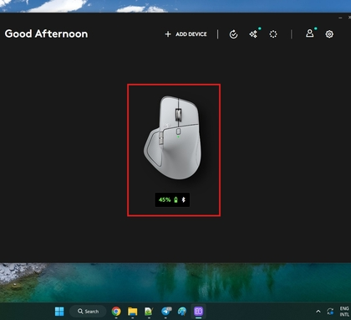
Step 3: Access Point & Scroll Settings
After selecting your device, navigate to the 'Point, Scroll, and Press' settings. This section allows you to modify a variety of mouse functionalities, such as thumb wheel behavior and scroll wheel sensitivity. Click on 'Pointer Speed' to proceed.
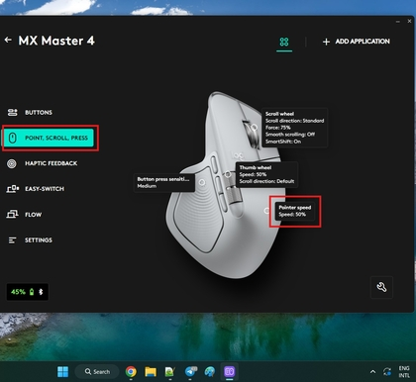
Step 4: Adjust Pointer Speed
Here, you can adjust the pointer speed according to your preference. By default, the speed is set to 50%, which provides moderate movement. Slide the control towards 0% for slower movement or towards 100% for faster movement depending on your needs.
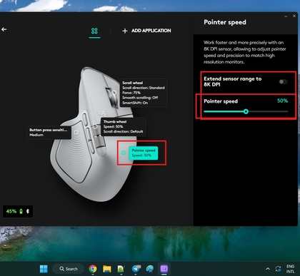
Step 5: Extend Sensor Range to Adjust DPI
If you wish to adjust the DPI, select the 'Extend Sensor Range' option to unlock higher DPI values. Standard settings are often set around 400-800 DPI, but activating this feature allows you to extend it up to 8,000 DPI for high-precision tasks, such as gaming or graphic design.

